Send exchange-order

Or

Receiving order

Send order

Customer’s books

Exchange-cart

Add to exchange-cart



Remove from exchange-cart

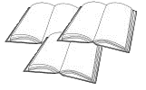

Buying

Vendor’s books

Cart

Add to cart



Remove from cart



I don't want to exchange, pay me!

Finish

Finalize

Finalize

Finalize

Finished transaction

Successful

Unsuccessful

**Customer’s side Common Vendor’s site**

Handling exchange-order

Accept

Refuse

Finalized transaction

Exchange

Cash